b) Factual: Where were most executions held?
Factual: Why were revolutionary courts set up in the first place?
Inferential: Why was this period called the "Reign of Terror"?
Inferential: Were the victims of the "Reign of Terror" primarily peasants or nobles?
Vocabulary: Who were the sans-culottes?

d.)
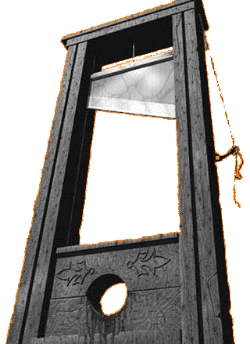
How did the invention of the guillotine make it possible for nearly 40,000 people to die during the Reign of Terror?
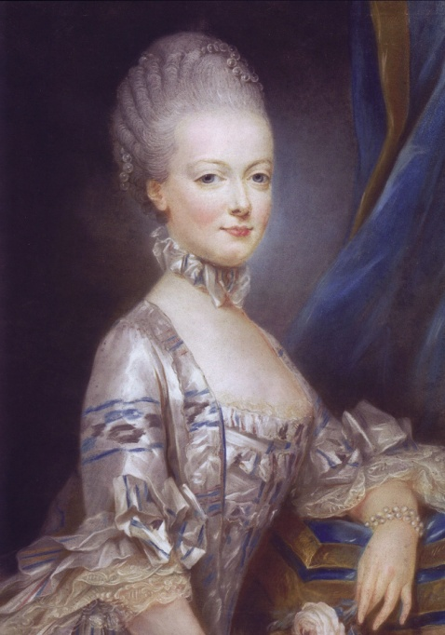
Why did the peasants desire Marie Antoinette to fall under the blade of the guillotine?

